Assembled and Unassembled Partitions – Styles

In our example, we will estimate 1000 assembled sets created with a length partition with 3 slots combined with a width partition with 5 slots, therefore the quantity per set will be 5 and 3 respectively to produce each finished assembled partition set.

In order to create assembled partitions, the style file and machine file should be properly defined. Note the valid style types at the bottom of the screen. This should be defined as an “P”artition style type if your partitions are cut from a sheet of board or ‘R”oll fed partition type if your partition machine are cut from a roll of paper. Partition styles have unique estimating logic. Valid designs and images already exist in the ASI database.

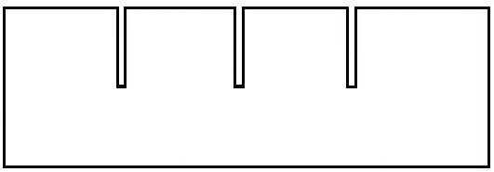

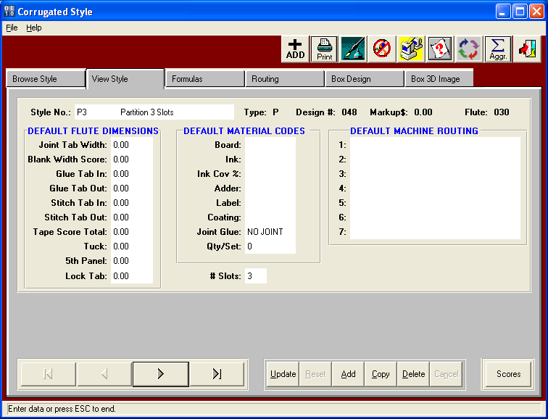

Assembled and Unassembled Partitions - Machines

The assemble machine should be defined as a unique department such as AP for Assemble Partition or any department code you may create under N-Z-4. The machine feed type is key so press F3 on this field and read the help text. . When the feed is "A" for Assembly, this machine will calculate run hours based on the quantity of sets per hour regardless of how many sheets or blanks are defined on that form (sheet). The flaw in this method is that a partition made with a combination of two 1 slot partitions will run as fast as an assembled partition with 3 slots combined with a 5 slot partition. In our example, if the assembly partition runs at 1000 per hour, it would require just 1 hour to assemble 3000 lengths and 5000 widths.

ASI recommends feed as "P" for Partition Assembly, as this machine will calculate run hours based on the total quantity of all partition blanks. If the Partition Assembly machine ran at 1000 parts per hour and we need 1000 final assembled sets then this would assemble as total of 5000 width partitions and 3000 length partitions. Therefore 8,000 parts divided by the machine run speed of 1000 or 8 hours. Both feed types of P or A will use the machine limits of Length, Width and Caliper as limits against the assemble sets dimensions length, width and depth respectively. The time required to cut each partition prior to the assembly operation ill be your normal box machinery that cuts the partitions such as slotters, slitters, die cutters and other machines.

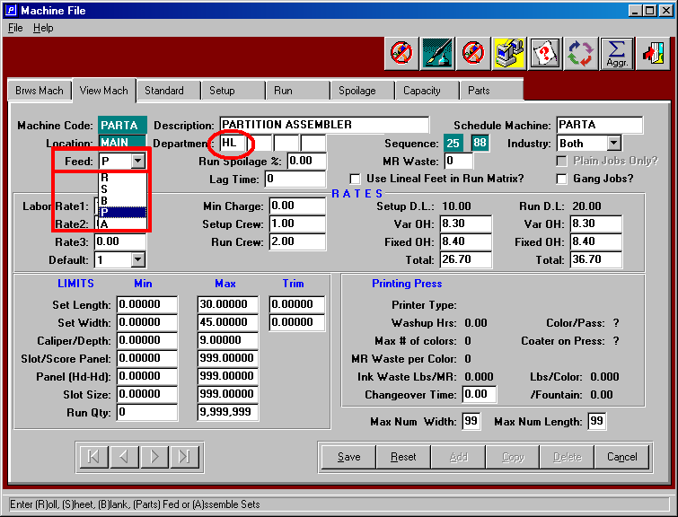

Assembled and Unassembled Partitions – Adding Estimates as Sets

Assembled Partitions are set estimates with two partition parts including a length partition and a width partition. When adding a new estimate you should click ASSEMBLED PARTITION button.
This button has unique logic for styles defined a type P for Partitions. The estimator simply enters the style code for the long and short partition, the partition LxWxD, Inside and Outside Cell Sizes and Board Grade. Then the system calculates the total blank size of each partition, sheet size and slot size. After adding the partition, you can click the SPEC Tab to modify either partition size or slot dimension or the LAYOUT tab to modify the layout of the die and/or sheet size of the board. If the partitions are combined on one sheet of board and cut together, then select the GOTO Button on the ESTIMATE tab to change the Form and Blank Numbers. To run both the Long and Short on one Die, change both partitions to Form 1, thus making this a combination die layout. The ADD button on the ESTIMATE tab can be used to add more parts such as an RSC as a third part of the set. Likewise, the COPY button can be used to copy a partition to run as a drop of sheet on another die layout as another sheet size.

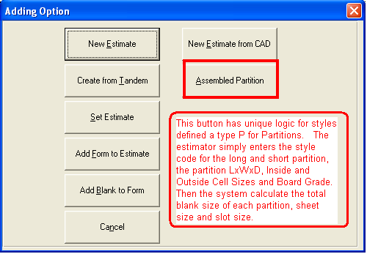

Assembled and Unassembled Partitions – Adding Parts

After selecting the PARTITION estimate button, the system will prompt for the length, width and height (depth) of the final 3D assembled partition, the length style, width style, inside cell size, external cell size and board grade. The partition assembly machine limits the length, width and caliper thickness are compared against the partition 3D dimensional length, width and depth respectively. If the limits are too small or too large, the assembly machine will not transfer to the machine routing.

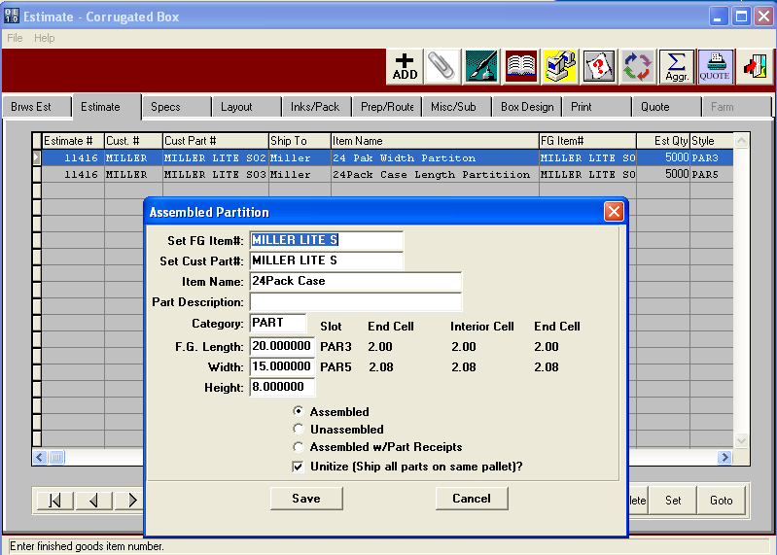

Assembled and Unassembled Partitions – Adding Parts

Adding extra parts is simply adding each part as if the item were a separate estimate.
After adding the 3D partition, you can click the ADD button to add another part such as an RSC or Packaging Case or press the COPY button to duplicate a partition that will be cut on another die layout. If the partitions are combined on one sheet of board and cut together, then select the GOTO Button to change the Form and Blank numbers to transform this into combination sheet layout. Please note, this example shows form 1 and form 2 which means that each partition will be cut from a unique sheet. Each sheet form can be made of different material and can be purchased from different vendors. Equally important is the quantity per set which indicates how many parts of each item. Since we are estimating 1000 sets, we will need 3000 lengths and 5000 widths.

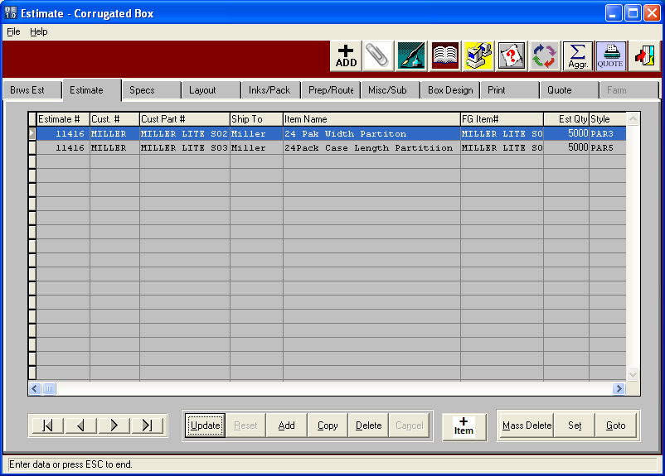

Assembled and Unassembled Partitions – Layout of Sheets

Each partition if cut from unique sheets require a separate layout page. In this example, I have die cut sheet known as form 1 as a three up die cut on the ward machine.

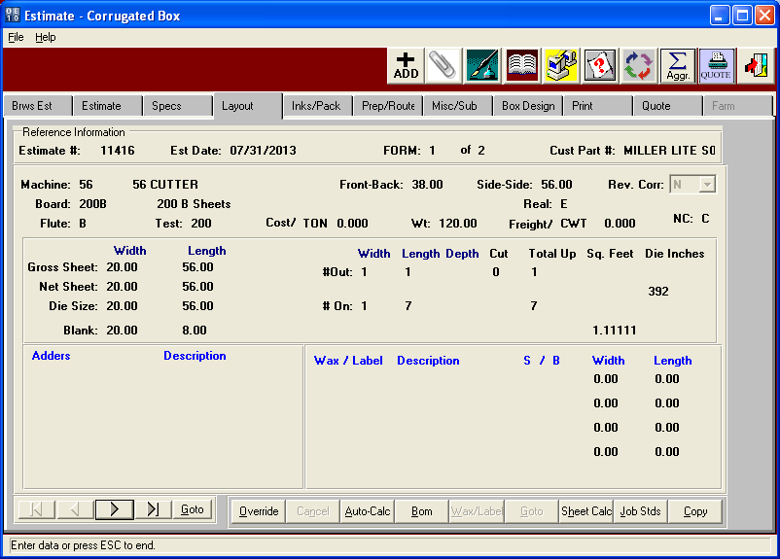

Assembled and Unassembled Partitions – Layout of Sheets

Each partition if cut from unique sheets require a separate layout page. In this example, I have die cut sheet known as form 2 as a four up die cut on the ward machine.

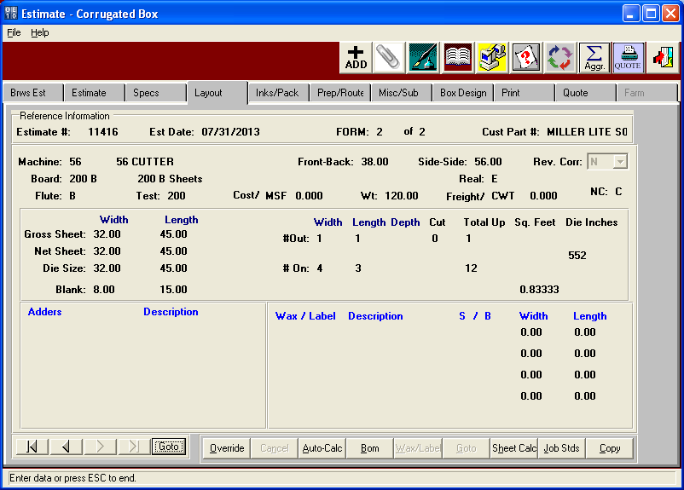

Assembled and Unassembled Partitions – Packing Requirements

Entering the freight and packing for an assembled set is defined on form 0, which can be accessed by pressing the back arrow keys. This any set or partition were shipped unassembled, this screen would not be available. Packing for each partition is defined as normal and can define how to unitize each partition on a pallet for delivery to the partition assembly machine.
Please note, the freight costs will only be used for Form 0 for assembled sets.

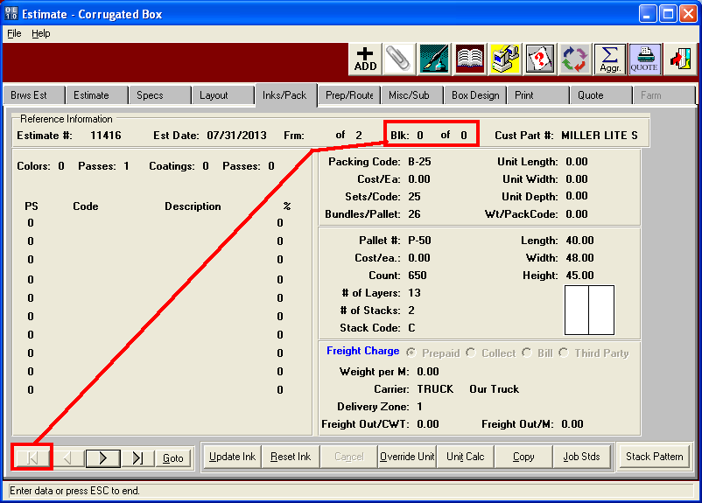

Assembled and Unassembled Partitions – Machine Routing

The machine routing will import machines based on each style’s routing matrix defined.
Therefore, form 1 will have a machine routing that could be different from form 2.
The partition assembly should be on the last form and will calculate based on the feed type.

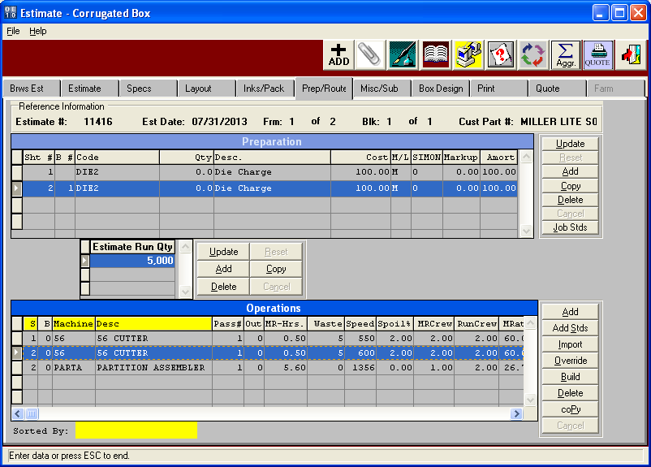

Assembled and Unassembled Partitions – Whatif and Items

The estimate will calculate the cost based on all materials and machine labor for the entire assembled partition set. The Item button will display the cost of each part, whereas the print folder displays the cost and sell price of the entire assembled set.

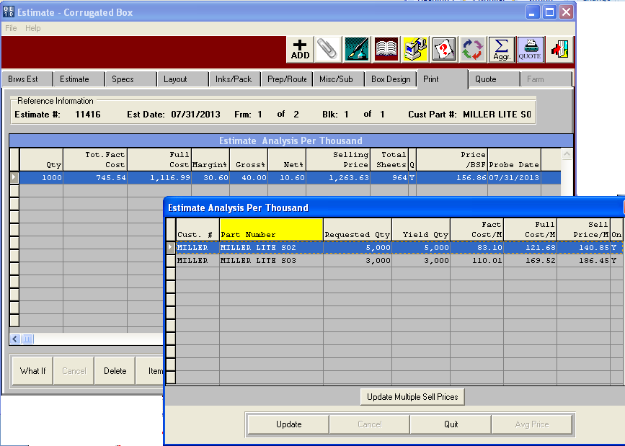

Assembled and Unassembled Partitions – Estimate Print Out

The estimate will print each partition with costs showing the cost of each component if estimated separately. However, the summary,will roll the costs of each part into the set and display the costs of the assembled partition as a set.

